Carrera 37 N° 25A- 38, Apto 301  
111321, Teusaquillo  
Bogotá – Colombia

31th may 2021

Dear Chief Editor   
Friedrich Recknagel  
Ecological Informatics  
Adelaide, Australia

We are writing to submit the enclosed manuscript of our research paper entitled “*Simulated LoRa Sensor Network as support for route planning in solid waste collection*” which is the result of a research carried out at the computer systems and industrial engineering department at Universidad Nacional de Colombia, Bogotá, thus, we put it under consideration by The journal Ecological Informatics.

We consider this paper is a valuable contribution to the state-of-the-art in the application of IoT solutions to city logistics and planning, particularly in real implementation of a systems for waste management that improve environmental sustainability; the main contributions are:

* Assembling three different circuits for measurement devices, using a long distance transmission technology LoRa.
* Configuring a LoRaWAN, managing the information flow and comparing transmission ranges of measurement devices.
* A simulation of waste generation in the streets of a district in Bogota, then we take advantage of simulated information to generate routes dynamically.
* A mobile application that shows container fulfillment levels, containers locations and shows generated routes on a map considering real-time traffic.

As authors we declare the originality of this work, thus, we confirm that no intentional plagiarism is presented in the manuscripts and that all ideas from other authors are properly referenced and cited. All the figures, tables and images are created or extracted from the original work of the authors.

We attest that this manuscript has not been published or put under consideration by other journals. All authors have approved the manuscript and agree to be submitted to Ecological Informatics, furthermore we declare that we have no conflicts to declare, nor financial or personal interests that could have appeared to influence the work reported in this paper.

Author Contributions are

Miguel A. Montañez: writing – original draft preparation, conceptualization, methodology, device assembling, test, simulation, system integration, formal analysis, mobile app development.   
Luis F. Niño: conceptualization, resources, project administration, methodology support, simulation, software validation, reviewing original draft.

For further information or requirement please contact the corresponding author Miguel Montañez by email to the address [mmontanezg@unal.edu.co](mailto:mmontanezg@unal.edu.co).

Yours respectfully

Miguel Montañez

Computer Systems Engineering Master Student

Universidad Nacional de Colombia, Bogotá

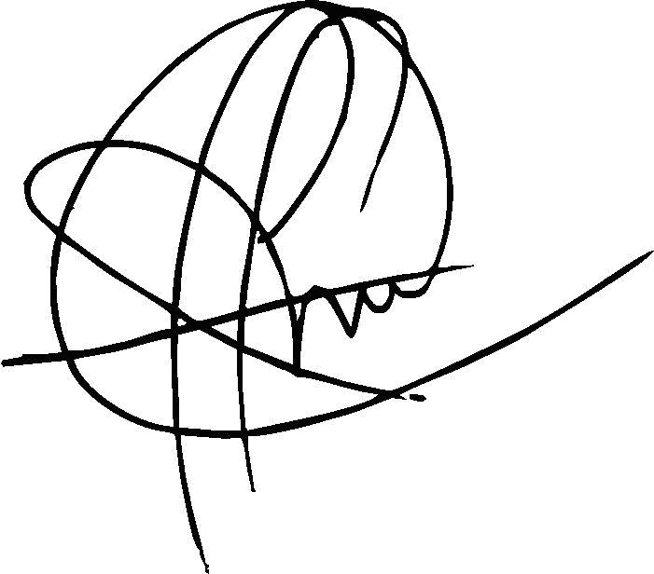

Luis Fernando Niño

Full Professor

Computer Systems and Industrial Engineering Department

Universidad Nacional de Colombia, Bogotá